Process in Linux

Changing hostname

echo $SHELL (what shell is in use) SHELL is just a variable

* USER – ubuntu
* Processes -bash,-bash, ps -u
* Shell = bin/bash
* PID = process ID
* TTY = terminal type
* CMD = name of command that launched the process

ps -u (process user)

ps -A (lists all processes running, with number index)

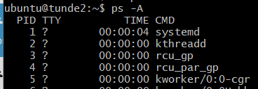

ps -u is also a process that processes other processes( see ps -ef which will show all process that are running).

ps -ef > process.log (will save all the output of ps -ef into the new file process.log. To view the output, cat process.log) . 

top (a command that gives you real time processes that are running). It will show processes using up system resources e.g zombie process which is not an effective process but consumes resources

exit top with q (quit)

atop gives more real time details about the processes running in the system. It is not a native command (is not part of the basic Linux install but can be added by installing it.

htop gives a high definition of the processes running.

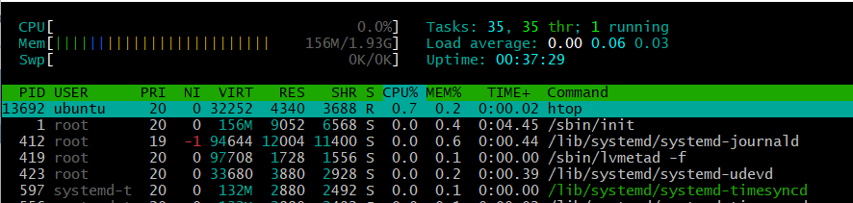

to kill a process use the kill

kill -9 will kill a parent process.